SIMATS ENGINEERING
ASSESSMENT TOOL 2: Case Study

COURSE NAME: | Cloud Computing and Big Data  Analytics | COURSE CODE: | CSA15

COURSE OUTCOME COVERED
CO3: Implement cloud-based solutions using cloud storage, web APIs, and platform services for real-world applications. (BL3)
Assessment Tool Weightage: 20%

Dave's Taxonomy: Precision (Level 3) Total Marks: 30 Question Count: 3

Code of Conduct
I (AMARA SATWIKA/192525204) (Name / Reg No) certify that this submission is my original work and that I have adhered to the guidelines specified for this assessment.
I understand that any violation of academic integrity rules will result in disciplinary action. Signature of the student: A.SATWIKA

Assessment Tasks

Case Study
- Case 1: A food delivery company wants to deploy a cloud-native backend with web APIs, browser clients, and shared cloud storage for receipts and delivery images. Propose the architecture and explain the role of each component.
- Case 2: A media startup must decide between SAN-backed storage, object storage, and serverless processing for video upload workflows. Analyze the case and recommend a deployment model.
- Case 3: A smart city platform needs low-latency decision making near sensors while still using the cloud for analytics. Analyze the use of edge computing and fog computing in this environment.

Case Study Rubric
Criteria | Weightage | Level 4 -  Exemplary | Level 3 -  Proficient | Level 2 -  Developing | Level 1 -  Beginning
Understanding of Case | 25% | Clearly identifies all technical and business requirements | Identifies most requirements | Basic understanding only | Poor understanding of case
Application of  Concepts | 25% | Applies suitable cloud concepts and tools effectively | Good  application with minor issues | Partial application | Weak or incorrect application
Analysis | 20% | Strong analysis with clear trade-off reasoning | Reasonable analysis | Limited analysis | Minimal analysis
Solution  Design | 20% | Solution is feasible, practical, and well justified | Reasonable solution with minor gaps | Basic solution | Unclear solution
Clarity | 10% | Wellstructured and easy to follow | Mostly clear | Somewhat unclear | Poorly organized

CASE STUDY 1
Title
Cloud-Native Architecture for a Food Delivery Company

Case Description
A food delivery company wants to deploy a cloud-native backend that supports web APIs, browser-based clients, and shared cloud storage for receipts and delivery images.

Objective
To design a scalable cloud-native architecture for a food delivery platform using web APIs, cloud storage, databases, and browser clients.

Requirements
The system should provide:
- Customer access through a web browser
- Restaurant and delivery-partner access
- REST API communication
- Order management
- Payment and receipt storage
- Delivery image storage
- Centralized database
- Monitoring and logging
- Scalability during peak orders

Role of Each Component
Component | Role
Web Browser | Provides the interface for customers, restaurants, and delivery partners
API Gateway | Receives and routes API requests
REST APIs | Enable communication between frontend and backend services
Order Service | Handles food orders and delivery status
User Service | Manages customer and delivery-partner information
Cloud Database | Stores structured data such as users, restaurants, and orders
Object Storage | Stores receipts, food images, and delivery proof images
Notification  Service | Sends order and delivery notifications
Monitoring Service | Tracks application performance and errors

Order Processing Flow
Customer
↓
Browser
↓
REST API
↓
Order Service
↓
Cloud Database
↓
Restaurant
↓
Delivery Partner
↓
Order Delivered
↓
Delivery Image → Cloud Storage

Cloud Storage Selection
Object storage is recommended for receipts and delivery images because these files are independent objects that may grow to a large volume. It provides scalable storage and convenient API-based access.

Analysis
The food delivery system requires high availability and scalability because order volume can change significantly during lunch, dinner, weekends, and special occasions.
A cloud-native design separates application services from storage and database components. REST APIs provide communication between clients and backend services, while object storage handles large files without placing unnecessary load on the transactional database.
The architecture also allows individual services to scale according to demand.

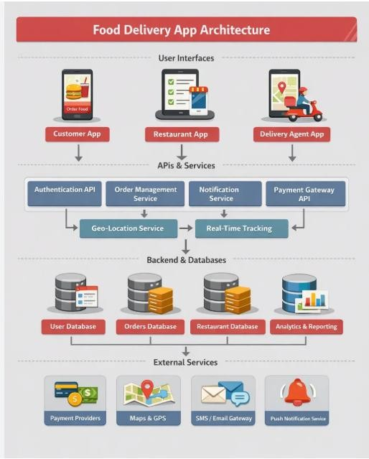

Recommended Solution
A cloud-native API-based architecture with object storage and a managed cloud database is recommended. The system should use:
- HTTPS REST APIs
- API gateway
- Managed database
- Object storage
- Notification service
- Monitoring and logging

Advantages
- Scalable during peak demand
- Easy access through browsers
- Centralized data management
- Reliable file storage
- API-based integration
- Easier monitoring and maintenance

Conclusion
The proposed cloud-native architecture provides a practical solution for the food delivery company. Web APIs handle application communication, cloud databases store structured information, and object storage stores receipts and delivery images. This combination provides scalability, accessibility, and efficient resource management.

CASE STUDY 2
Title
Storage and Serverless Processing Model for a Media Startup

Case Description
A media startup needs to select between SAN-backed storage, object storage, and serverless processing for its video upload workflow.

Objective
To analyze the three technologies and recommend a suitable cloud deployment model for large-scale video upload and processing.

Requirements
The media startup requires:
- Large-scale video storage
- Video uploads from users
- Automatic video processing
- Thumbnail generation
- Multiple video formats
- Scalable infrastructure
- Efficient storage
- Reduced server management

Comparison
Feature | SAN-Backed Storage | Object Storage | Serverless Processing
Primary  Purpose | High-performance block storage | Large-scale object storage | Event-based computation
Data Type | Blocks | Objects | Processing workloads
Scalability | High | Very High | Automatic scaling
Best Use | Databases, VM workloads | Videos, images, backups | Video processing tasks
Access | Block-level | API/HTTP | Function invocation
Server  Management | Required | Low | Minimal
Video Storage | Possible | Excellent | Not primarily storage
Video Processing | Application-dependent | Stores input/output | Excellent for eventdriven tasks

Role of Each Technology

SAN-Backed Storage
SAN storage provides block-level storage with high performance. It is suitable for workloads such as databases and systems that require direct disk access.
However, it is not the most efficient primary storage model for a media startup storing a large collection of independent video files.

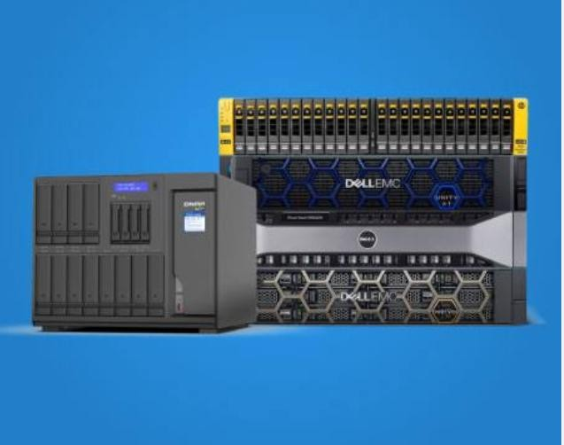

Object Storage
Object storage is highly suitable for storing videos because each video can be stored as an independent object with metadata.
It can support:
- Large video collections
- Different video formats
- Thumbnails
- Metadata
- Backup copies

Serverless Processing
Serverless functions can automatically execute when a new video is uploaded.
Possible processing operations include:
- Video format conversion
- Thumbnail generation
- Metadata extraction
- File validation
- Processing notifications
Recommended Deployment Model
The recommended solution is:

Object Storage + Serverless Processing
with SAN-backed storage used only when a specific high-performance block-storage workload requires it.

Workflow
Video Upload
↓
Object Storage
↓
Upload Event
↓
Serverless Processing
↓
Format Conversion
↓
Thumbnail Generation
↓
Processed Video
↓
Object Storage
↓
User Access

Analysis
Using SAN-backed storage as the primary video repository can provide strong performance but may introduce unnecessary infrastructure management for a startup.
Object storage is more appropriate for large collections of independent video files because it is designed for scalable object-based data storage.
Serverless processing complements object storage because the processing function can execute when a video upload event occurs. This eliminates the need to maintain continuously running processing servers for intermittent workloads.

Trade-Off Analysis
Option | Advantage | Limitation
SAN | High performance | More infrastructure management
Object  Storage | Highly scalable and suitable for media | Not a traditional block device
Serverless | Automatic execution and scaling | Function execution limits may apply

Final Recommendation
The media startup should adopt:

Object Storage → Event Trigger → Serverless Processing → Object Storage
SAN-backed storage can be retained for specialized workloads such as high-performance databases or applications requiring block-level access.

Conclusion
For a media startup, object storage combined with serverless processing provides the most practical deployment model. Object storage handles large-scale video storage, while serverless functions automatically process uploaded videos. This architecture reduces infrastructure management and supports future growth.

CASE STUDY 3
Title
Edge and Fog Computing for a Smart City Platform

Case Description
A smart city platform requires low-latency decision-making near sensors while continuing to use cloud computing for large-scale analytics.

Objective
To analyze the use of Edge Computing and Fog Computing in a smart city environment and design a system that provides rapid local decisions while using the cloud for centralized analytics.

Requirements
The smart city platform requires:
- Real-time sensor processing
- Low latency
- Traffic monitoring
- Local decision-making
- Processing of data from multiple sensors
- Centralized cloud storage
- Long-term data analytics
- Reduced network traffic
Role of Edge Computing
Edge computing processes data near the sensor or device.

Examples
- Detecting traffic congestion
- Detecting abnormal sensor readings
- Controlling traffic signals
- Detecting emergency situations

Benefit
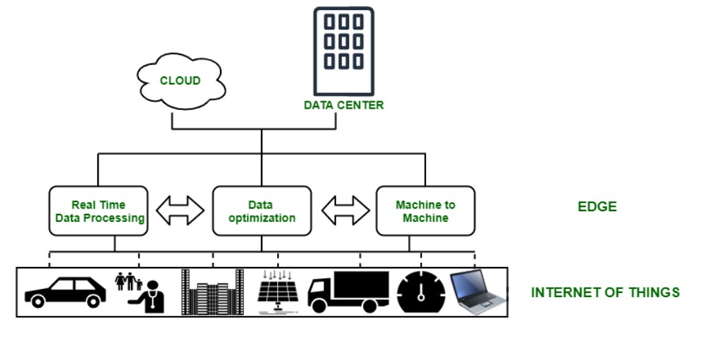
The main advantage is very low latency, since data does not need to travel to a distant cloud server before a local decision is made.

Role of Fog Computing
Fog computing provides an intermediate processing layer between edge devices and the cloud.
It can combine information from several nearby edge devices.

Example
Traffic sensors from several roads can send information to a local fog node. The fog node analyzes the combined information and determines whether a particular area has traffic congestion.

Benefits
- Local-area processing
- Low latency
- Combines data from multiple sensors
- Reduces cloud communication
- Supports coordinated decisions

Role of Cloud Computing
The cloud handles large-scale tasks such as:
- Long-term data storage
- Historical traffic analysis
- Big data processing • Machine learning
- City-wide reporting
- Dashboard generation

Comparison
Parameter | Edge Computing | Fog Computing | Cloud Computing
Processing  Location | Near sensor/device | Local network layer | Central cloud
Latency | Very Low | Low | Higher for real-time local decisions
Main Purpose | Immediate decisions | Local coordination | Large-scale analysis
Data Scope | Individual device | Multiple nearby devices | City-wide data
Storage  Capacity | Limited | Moderate | Very High
Example | Traffic signal control | Junction-level traffic analysis | City-wide traffic analytics

Decision-Making Example

Emergency Vehicle
Emergency Vehicle Detected
↓
Edge Device
↓
Immediate Decision
↓
Traffic Signal Control
The edge layer handles the immediate response.

Traffic Congestion
Multiple Road Sensors
↓
Fog Layer
↓
Local Traffic Analysis
↓
Traffic Management Decision
The fog layer combines information from multiple nearby devices.

Historical Analysis
Traffic Data
↓
Cloud Storage
↓
Big Data Analytics
↓
Traffic Pattern Report
The cloud is used for long-term analysis and reporting.

Analysis
A cloud-only architecture may introduce additional latency when immediate decisions are required. Sending every sensor reading to the cloud can also increase network traffic.
Edge computing solves the latency problem by processing critical information near the source. Fog computing provides an additional coordination layer that can combine data from multiple edge devices.
Cloud computing remains important because it provides large-scale storage and computing resources for historical analysis and machine learning.
Therefore, the three technologies should be used together rather than treated as competing alternatives.
Recommended Solution
The recommended architecture is:

Edge → Fog → Cloud
- Edge: Immediate sensor-level decisions
- Fog: Local-area coordination
- Cloud: Centralized storage and advanced analytics

Advantages
- Very low response time
- Efficient network utilization
- Local decision-making
- Centralized analytics
- Scalable cloud storage
- Better support for real-time smart city applications

Conclusion
The smart city platform should use a hybrid Edge–Fog–Cloud architecture. Edge computing provides immediate responses near sensors, fog computing coordinates data from multiple nearby devices, and cloud computing performs large-scale storage and analytics. This combination provides a practical, scalable, and low-latency solution for smart city applications.

